PLYWOOD FLOOR

Assembly Manual
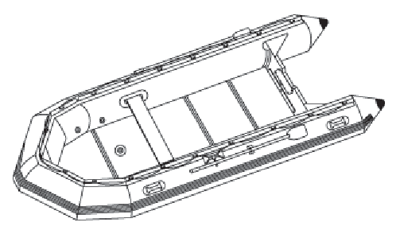
Unfold the Hull
Clear a flat space (making sure it is clean and free of sharp objects) and unfold your boat. Remove the hull from its box and take it out of the boat bag. Unroll the hull so it laid out flat.

Inflate slightly
The Inflatable Boats can be inflated either with a hand pump or with electric pump. The electric pump can inflate the boats to a moderate pressure and save a lot of time, but boat will need to be finished off with a hand pump. Inflate all hull chambers to approximately 30% full in order to make floorboard insertion easier.

Floorboard Assembly

4-boards model
- Place floorboard No.1 at bow part, No.4 at transom part, and No.2 + No.3 Make sure that keel valve is located at the center of No.1 board's hole.
- Press down No.2 + No.3 at the same time to be jointed well and flatly.
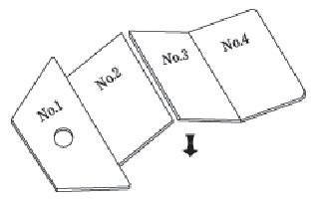

5-boards model :
Place floorboard as follows :
- Bow board, No.1, No.4, and No.2 + No.3. Make sure that keel valve is located at the center of No.2 board's hole.
- Press down No.2 + No.3 at the same time for 5 floorboards boat at the same time for 6 floorboards boat to be jointed well and flatly.

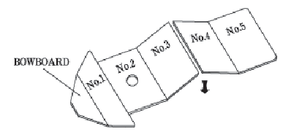
Stringers
Insert stringers into side edges of floorboards. For easy fitting of stringers, place oar under boat hull.

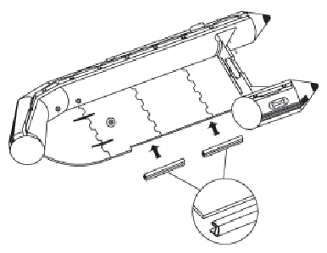

Note: Plywood floors somewhat hard to assemble at the first time, but after two or three times of using a boat, it will be easier to assemble

